Student Performance Prediction System

Project Id: AIML-18

Name : Pawani Gupta (Team Leader)
Class Roll Number:13
University Roll Number : 2028463
Section and Group: P G1

Name : Riya Gupta
Class Roll Number:13
University Roll Number : 2028477
Section and Group: P G1

Name : Tamanna Bhinder
Class Roll Number:24
University Roll Number : 2028507
Section and Group: P G1

- Problem Description 3
- Architecture 4
- Models model 5
- Evaluation metrics used 6
- Preliminary Results and Visualizations 7
- References 8

- Problem Description
Heart disease remains one of the leading causes of mortality worldwide, making early detection and prevention critically important. Traditional diagnosis methods often require extensive medical testing, which can be time-consuming, costly, and not always accessible in all regions. Therefore, there is a need for an efficient, data-driven approach to identify individuals at risk of heart disease using readily available clinical and lifestyle parameters.
This project aims to develop a Heart Disease Prediction System using machine learning techniques. The system analyzes patient data such as age, blood pressure (BP), cholesterol level, body mass index (BMI), lifestyle habits (smoking, alcohol consumption, physical activity), stress levels, sleep patterns, and medical history (diabetes, hypertension, family history). By leveraging these features, the model predicts whether a person is at high risk or low risk of developing heart disease.
The core objective is to:
- Build a predictive model that can classify individuals based on their risk level.
- Apply data preprocessing techniques such as handling missing values, encoding categorical variables, scaling features, and managing outliers.
- Train multiple machine learning models and evaluate their performance using metrics like accuracy, precision, recall, and F1-score.
- Identify the most effective model for accurate and reliable prediction.
This system can assist healthcare professionals in early diagnosis and also serve as a preventive tool for individuals by providing insights into their cardiovascular health risk based on lifestyle and medical attributes.

1.1 Dataset Description
The dataset used in this project consists of patient health records and lifestyle-related attributes that are relevant for assessing the risk of heart disease. It includes both numerical and categorical features, providing a comprehensive view of an individual’s medical condition and daily habits.
Each row in the dataset represents a unique individual, while each column corresponds to a specific feature influencing cardiovascular health.
Features in the Dataset
- AGE: Represents the age of the individual. Age is a significant risk factor, as the probability of heart disease increases with advancing age.
- BP (Blood Pressure): Indicates the blood pressure level of the individual. High blood pressure (hypertension) is a major contributor to cardiovascular diseases.
- CHOLESTROL: Represents the cholesterol level in the blood. Elevated cholesterol can lead to plaque buildup in arteries, increasing heart disease risk.
- gender: A categorical feature indicating the gender of the individual (e.g., Male/Female). Gender can influence susceptibility to heart conditions.
- bmi (Body Mass Index): Measures body fat based on height and weight. Higher BMI values are often associated with obesity, which is a known risk factor.
- family_history: Indicates whether there is a history of heart disease in the family (Yes/No). Genetic predisposition plays an important role in cardiovascular risk.
- smoking_status: Represents whether the individual is a smoker or non-smoker. Smoking significantly increases the risk of heart disease.
- alcohol_consumption: Describes the level of alcohol intake (e.g., Low, Moderate, High). Excessive alcohol consumption can negatively impact heart health.
- physical_activity: Indicates the level of physical activity (e.g., Low, Moderate, High). Regular exercise reduces the risk of heart disease.
- stress_level: Represents the individual’s stress level (e.g., Low, Moderate, High). Chronic stress can contribute to heart-related problems.
- sleep_hours: Indicates the number of hours the individual sleeps per day. Poor sleep patterns are associated with increased cardiovascular risk.
- diabetes: A binary feature (0/1) indicating whether the individual has diabetes. Diabetes is closely linked with heart disease.
- hypertension (Target Variable): A binary feature (0/1) indicating the presence of high blood pressure. In this project, it is used as a proxy indicator for heart disease risk classification.

Dataset Characteristics
- The dataset contains both numerical and categorical variables, requiring preprocessing techniques such as encoding and scaling.
- It includes medical, behavioral, and lifestyle factors, making it suitable for predictive modeling.
- The target variable is binary, making this a classification problem.

1.2 Flow Diagram
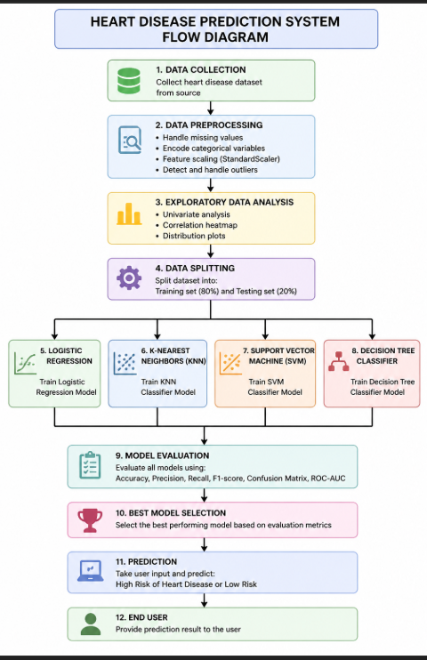

- Models Used(Applied/ Planned) Give a brief introduction of the models used
1. Pandas
- Purpose: Data manipulation and analysis
- Used for loading the dataset, handling missing values, filtering data, and performing operations on rows and columns.
- Provides DataFrame structures for efficient data handling.

2. NumPy
- Purpose: Numerical computations
- Used for handling arrays, mathematical operations, and reshaping input data for model prediction.
- Ensures efficient computation with large datasets.

3. Matplotlib
- Purpose: Data visualization
- Used to create plots such as pie charts, histograms, and model comparison graphs.
- Helps in understanding data distribution and model performance.

4. Seaborn
- Purpose: Advanced data visualization
- Used for creating heatmaps and statistical plots.
- Particularly useful for correlation analysis between features.

5. Scikit-learn (sklearn)
A machine learning library used for model building, preprocessing, and evaluation.
a) Preprocessing Module
- StandardScaler
  - Used to normalize feature values so that all features are on the same scale.
b) Model Selection Module
- train_test_split
  - Used to divide the dataset into training and testing sets.
c) Machine Learning Algorithms
- LogisticRegression
  - Used for binary classification of heart disease risk.
- KNeighborsClassifier (KNN)
  - Classifies data based on similarity (distance between data points).
- SVC (Support Vector Classifier)
  - Used to create optimal decision boundaries for classification.
- DecisionTreeClassifier
  - Builds a tree-like model for decision making and classification.
d) Evaluation Metrics
- accuracy_score
- precision_score
- recall_score
- f1_score
- confusion_matrix
These metrics are used to evaluate and compare the performance of different models.

- Evaluation metrics used
To evaluate the performance of the machine learning models, several standard classification metrics were used. These metrics help in understanding how well the model predicts the target variable and whether it performs reliably across different classes.
The evaluation is based on the confusion matrix, which consists of:
- True Positive (TP): Correctly predicted positive cases
- True Negative (TN): Correctly predicted negative cases
- False Positive (FP): Incorrectly predicted positive cases
False Negative (FN): Incorrectly predicted negative cases

4. Preliminary Results and Visualizations

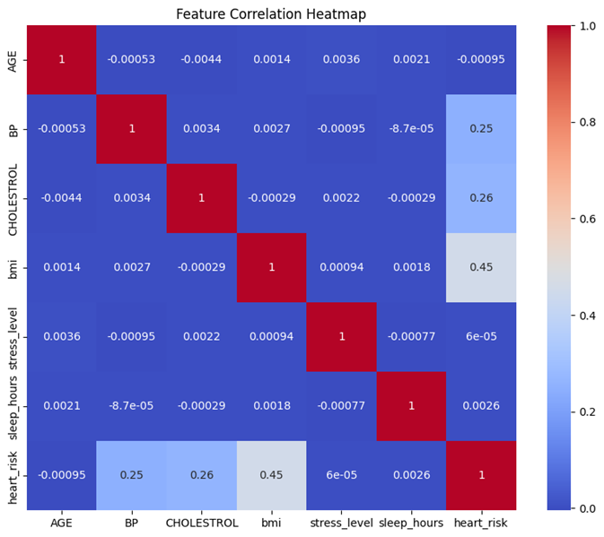

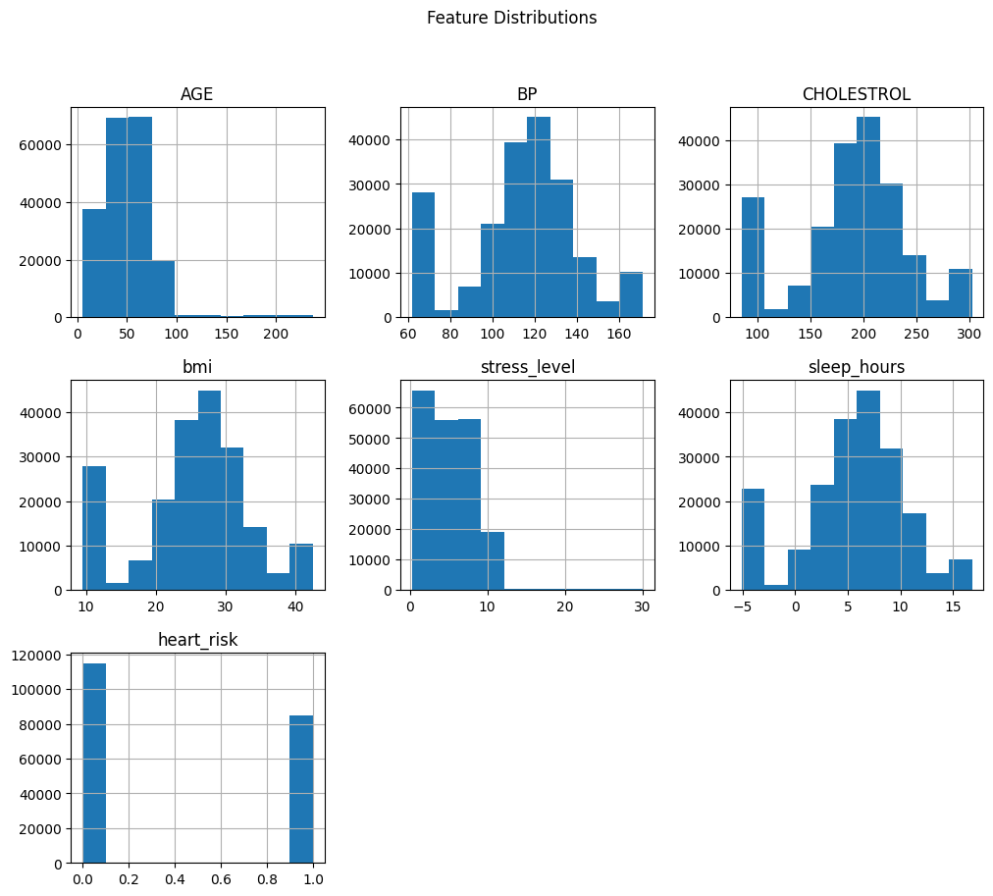
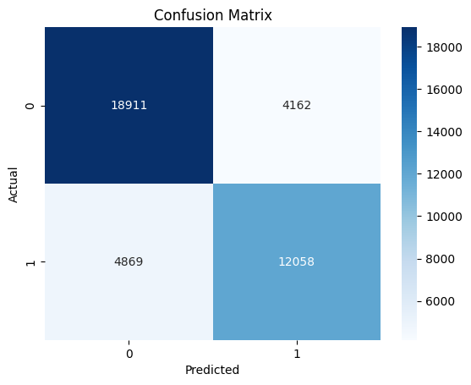

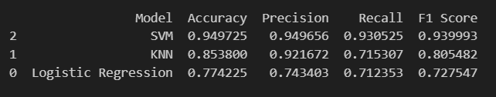

5. References:
Books:
- Let Us Python – Yashavant Kanetkar

Online Resources:
  - GeeksforGeeks – https://www.geeksforgeeks.org/
  - TutorialsPoint – https://www.tutorialspoint.com/cprogramming/index.htm
  - Stack Overflow – https://stackoverflow.com

